**VEHICLE INSURANCE SYSTEM**

.

**Project Members:**

**Ms . shivamma**

**Mr . Mohit G**

**Ms . Pavithra S**

**Ms . Devika L**

**Ms . Preethi R**

**Mr . Vasanth Kumar**

**Guided By :**

Prof. Indrakka Mali​

**Title :**

* Introduction
* Objective
* Technology to be Used
* Proposed System
* Snapshots
* Diagrams
* Conclusion

**Introduction:**

* The Vehicle Insurance System is a Web Application developed using spring boot and Structured Query Language as backend and Angular as frontend.
* The Goal of the application is to provide a dashboard to the insurance company where they can keep track of their customers.
* The vehicle insurance system is used to store customer details like customer id , name , phone number , Aadhar number , pan number , Driving license number and customer’s vehicle details.

**Objective :**

* The main objective of the Vehicle Insurance System is **to manage the details of Customer and Vehicle.**
* It manages all the information about customer and vehicle.
* **This project deals with the registration process for insurance.**
* The main idea is to implement a proper process to system .
* In our existing system contains a many operations registration, customer search, details of the customer etc.
* The organization can maintain computerized records without redundant entries.

**Software & Hardware used:**

**Software Requirements:**

* Operating System : Windows 11 or Windows 10
* Language : Java
* IDE : Spring Boot, Post Man
* Backend : Microsoft MySQL server
* Frontend : Angular JS

**Hardware Requirements :**

* CPU : Intel Pentium IV processor
* RAM : 512 MB or above

* Hard Disk : 2 GB hard disk space or minimum

**Proposed System:**

* The Online Vehicle Insurance website is to provide services for people who need insurance by getting help from the agents..
* **This is a web-related application that permits us to register for insurance**
* The main intention of building this website is to provide users to choose their budget and the best package for their vehicle. We have tried to maintain all the information of the insurance plan which is easily understandable to the users and makes it easy to find the plan.
* A user can log in to his account using his user id and name to share and update all the information like vehicle type, age, location, last insurance date, and contact number and he/she can submit the information.

**Back-End :**

* Core Java
* Spring Boot
* MySQLDatabase

**About Back-End:**

➢There are mainly four operations will be performed by the user Ex. Insert, update, retrieve/fetch, delete.

* These operation will be performed using the spring boot framework , and hibernate.
* For connectivity purpose we are using MySQL database. It is connected to the java and database.

# Working Of Back-End ;

➢There are mainly three stages

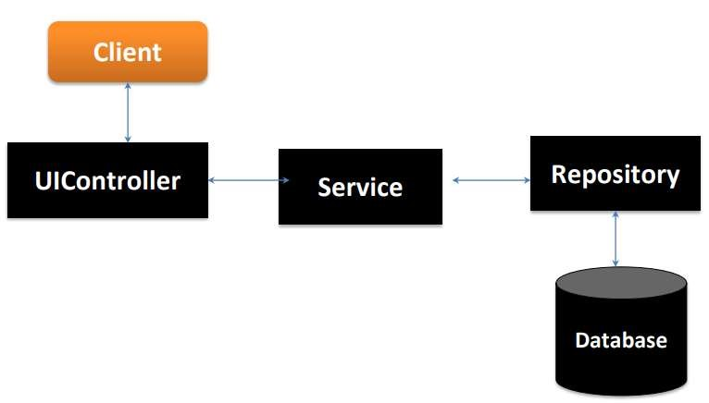

* UIController - In Spring Boot, the UIController class is responsible for processing incoming requests, preparing a model, and returning the view to be rendered as a response.
* Service - Components are the class file which contains @Service annotation.
* These class files are used to write business logic in a different layer.
* Repository - Repository is a specialization of

@Component annotation which is used to indicate that the class provides the mechanism for storage, retrieval, update, delete and search operation on objects

* Repository is directly connected with the database and then it can return to the repository and response to the service and it can return to the controller and then response send to the client.

resource utilization

​

**snap shots:**

Add Customer:

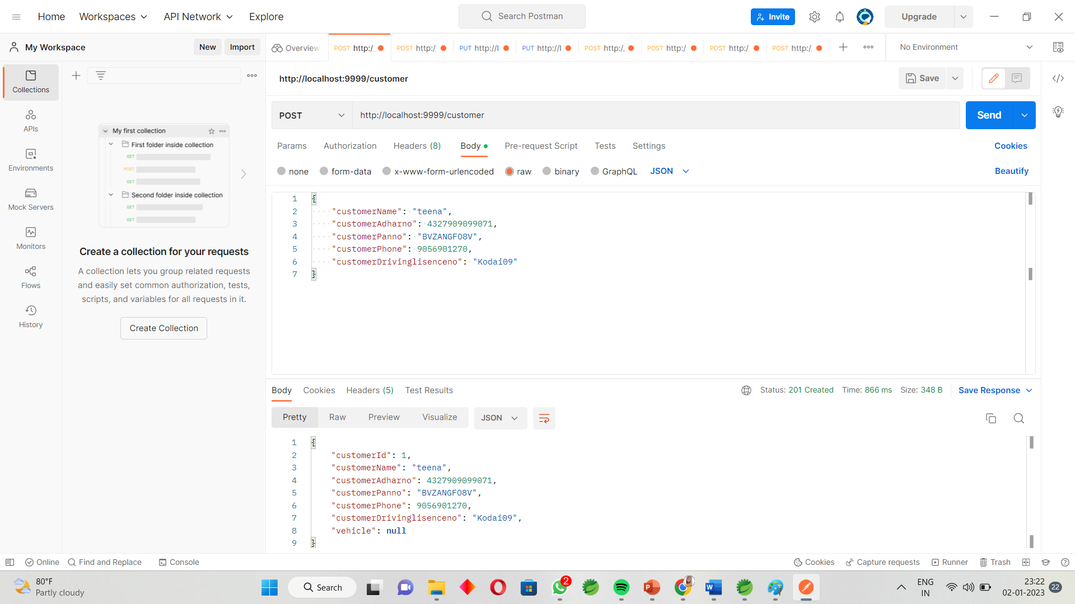

Get Customer By Id :

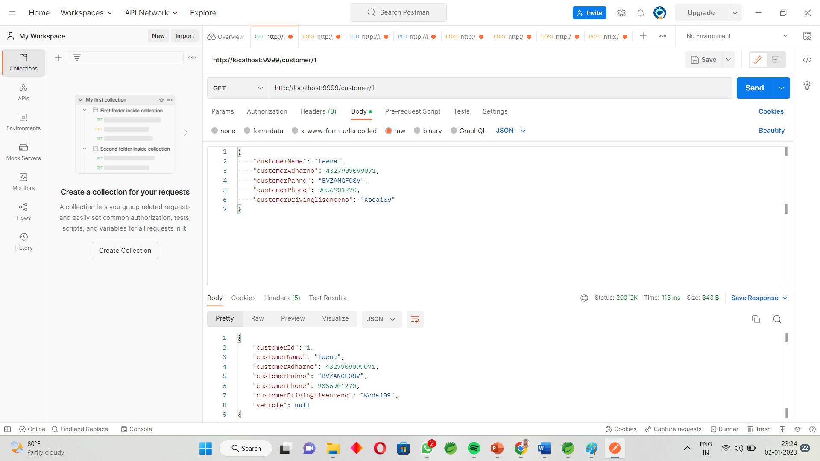

Update Customer By id:

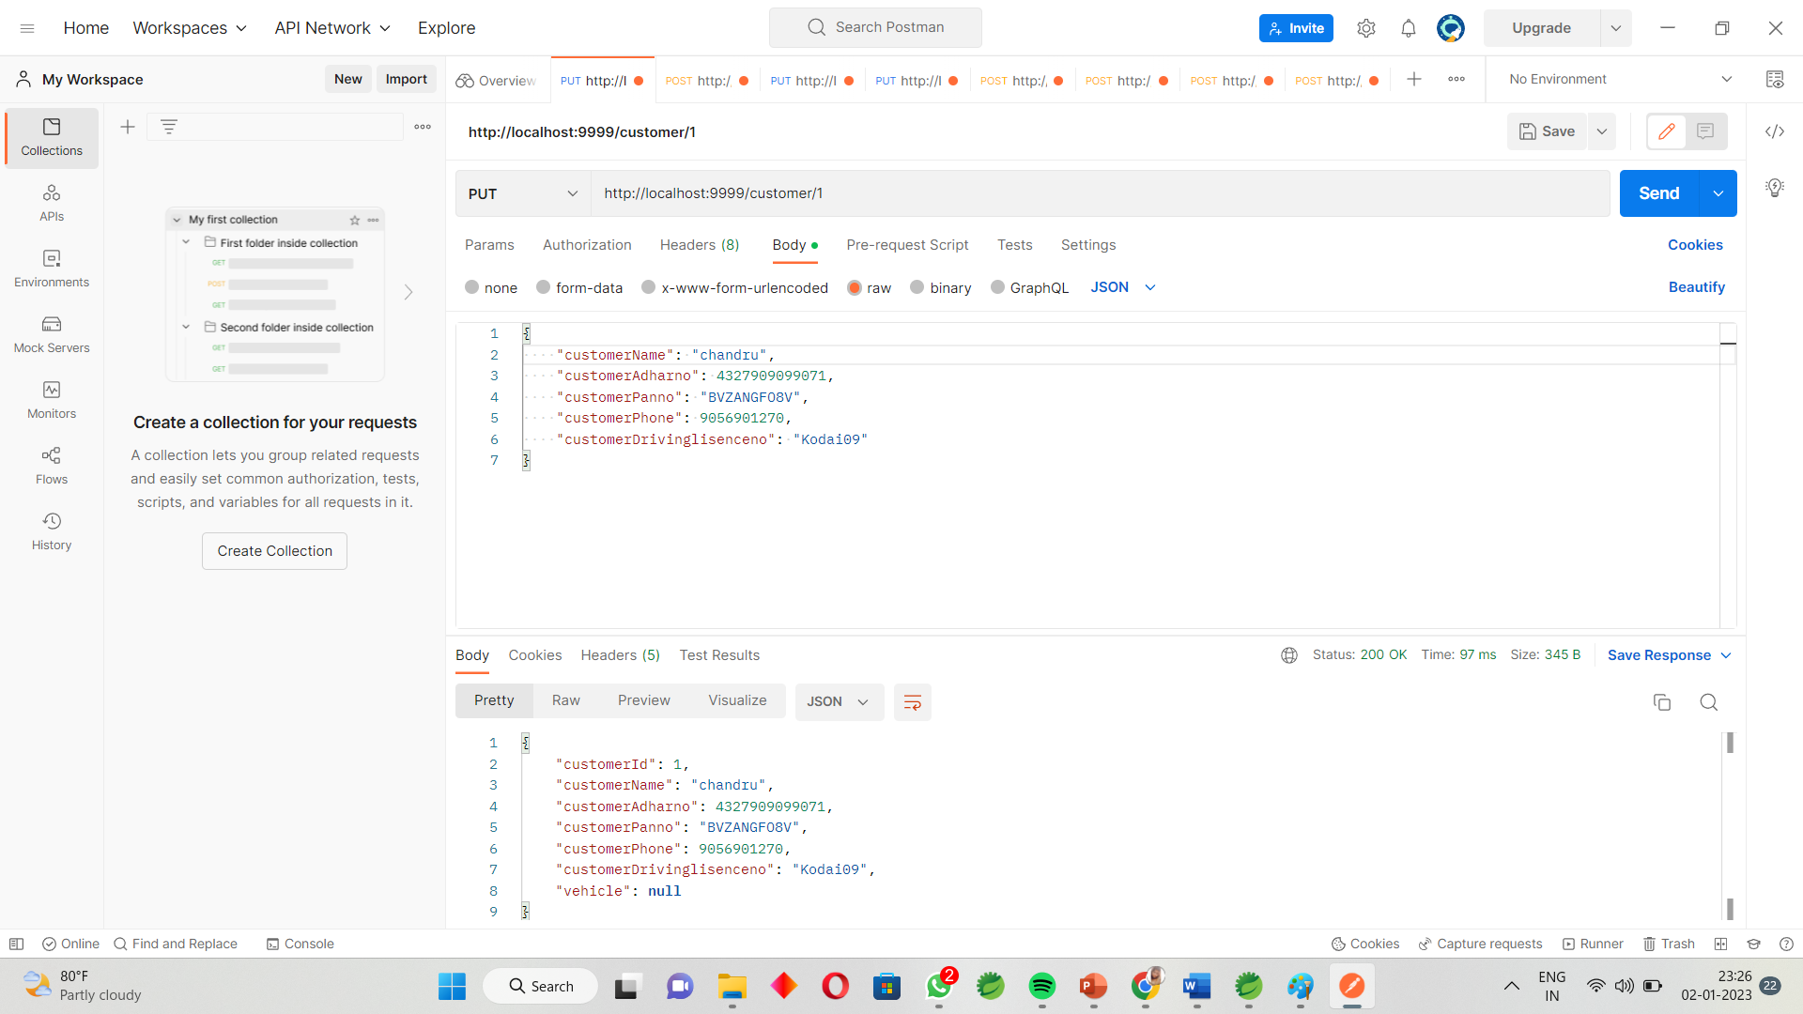

Delete Customer By Id: 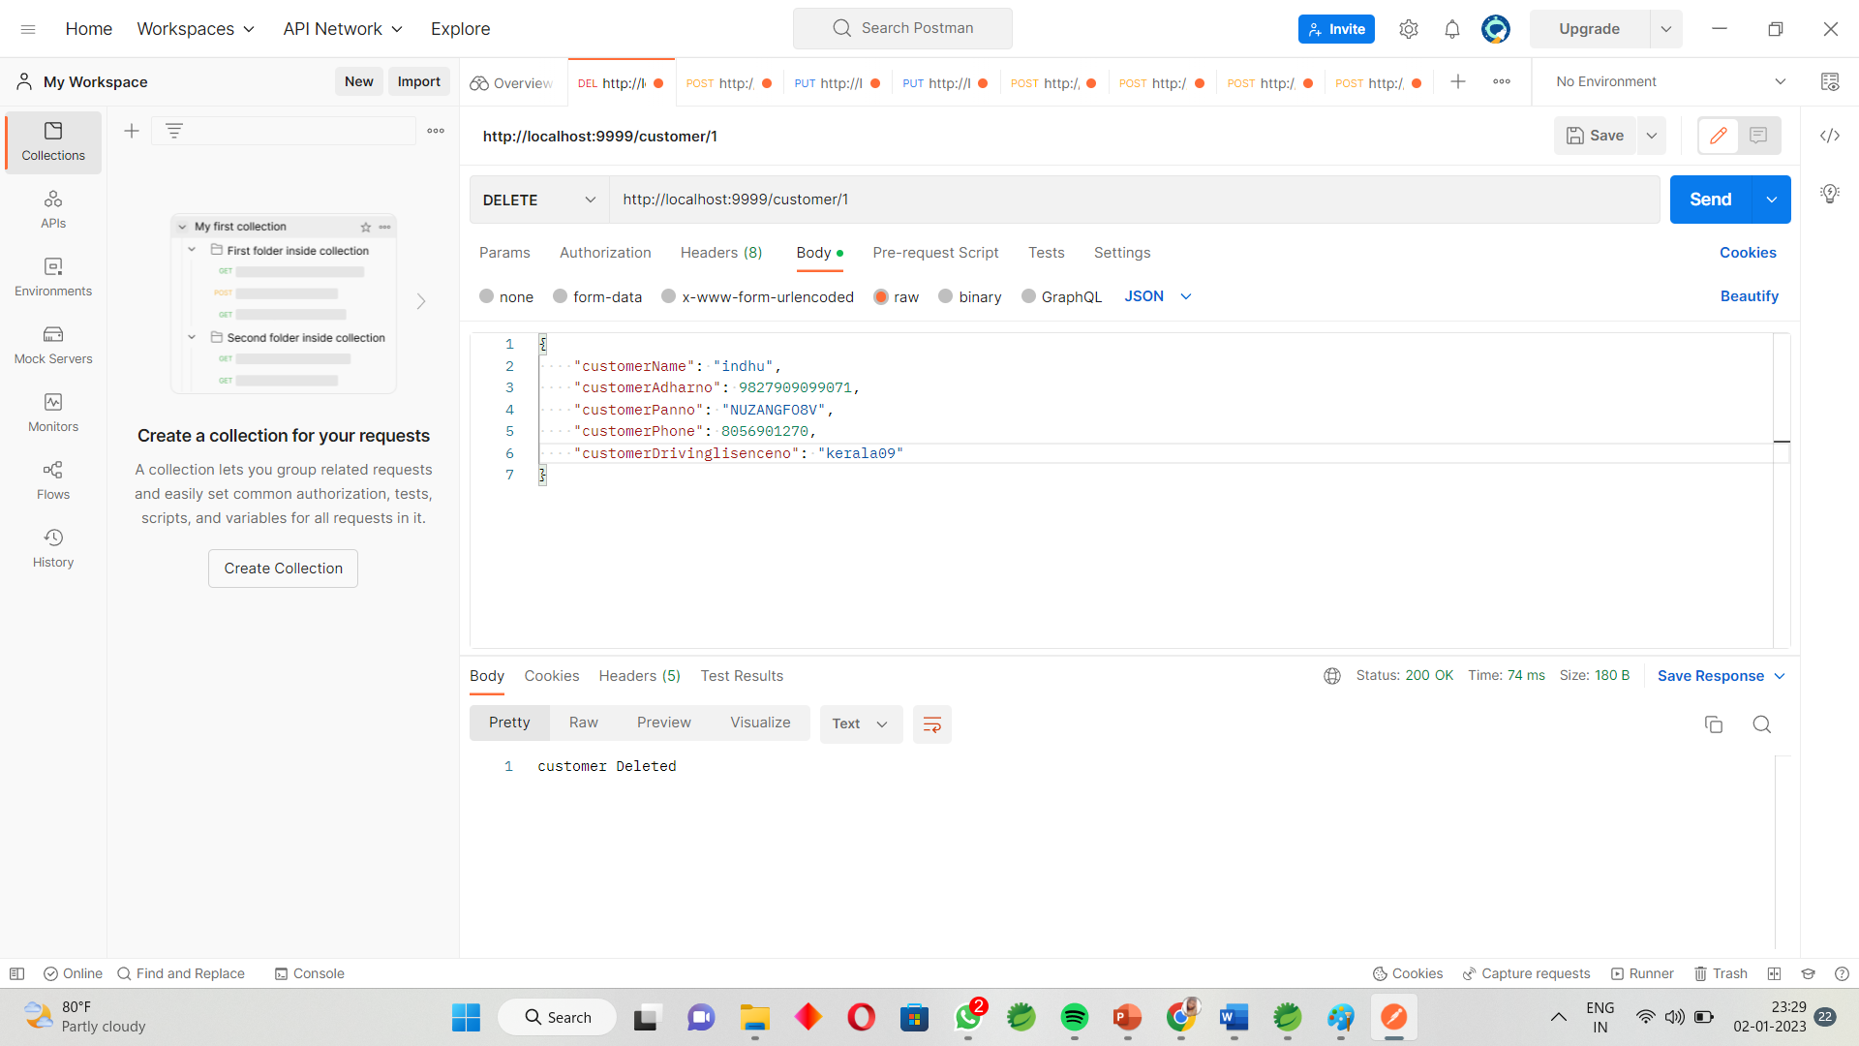

Find all Customers:

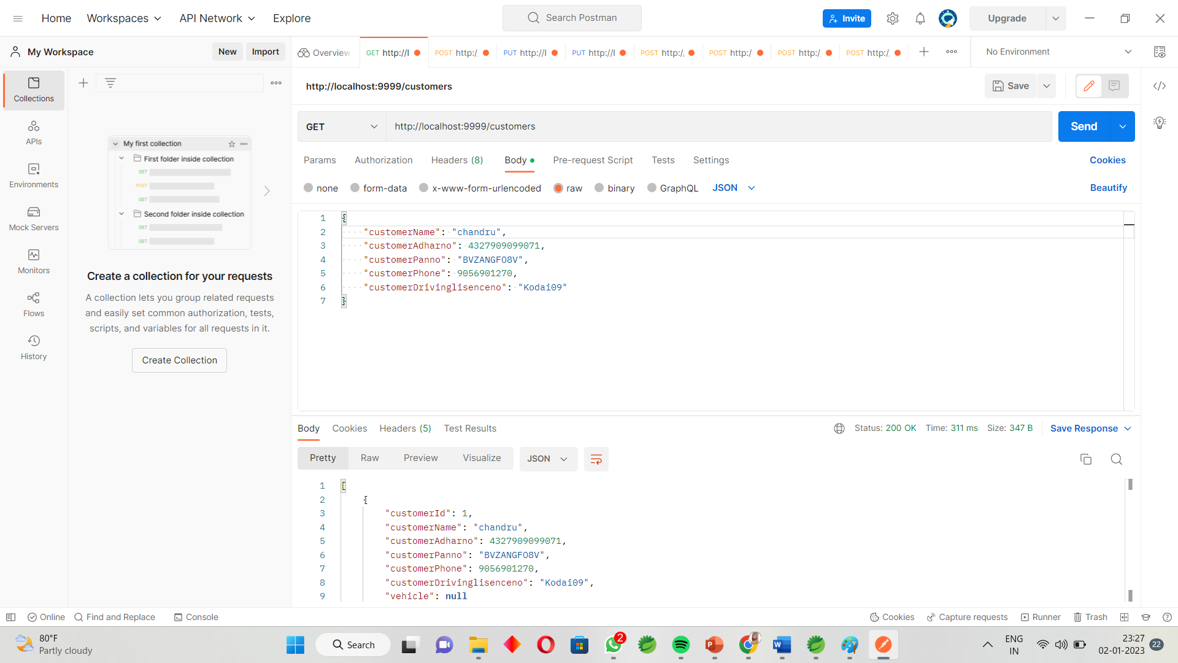

Assign Customer to vehicle:

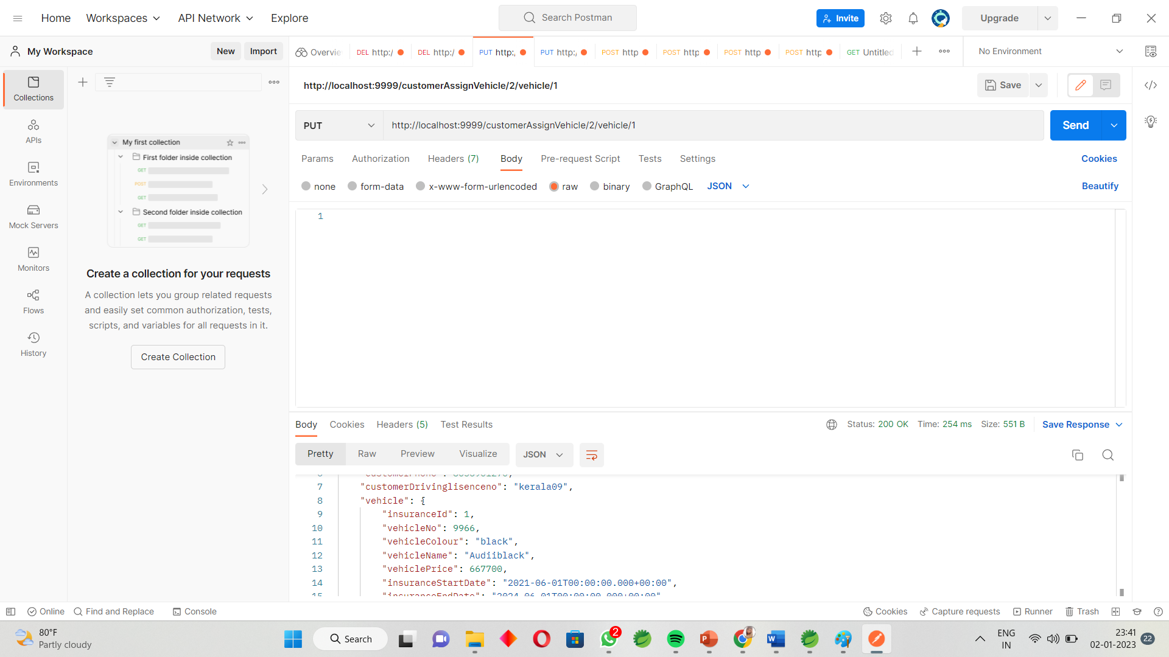

Add Vehicle :

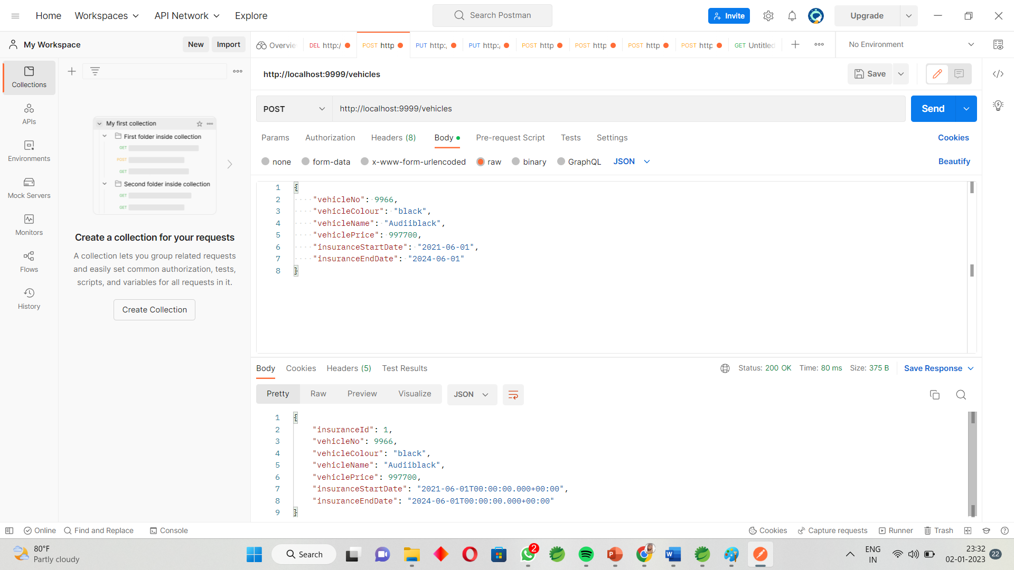

Get Vehicles By Id:

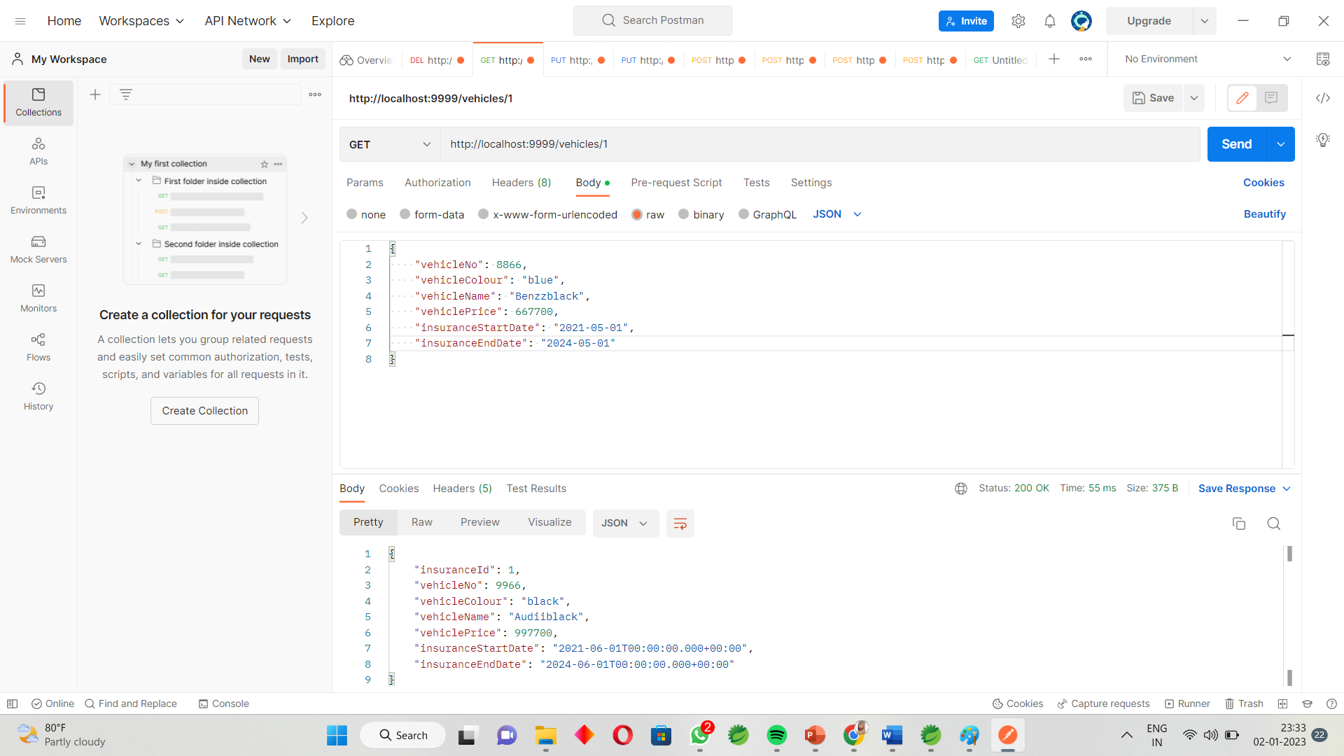

Delete Vehicles :

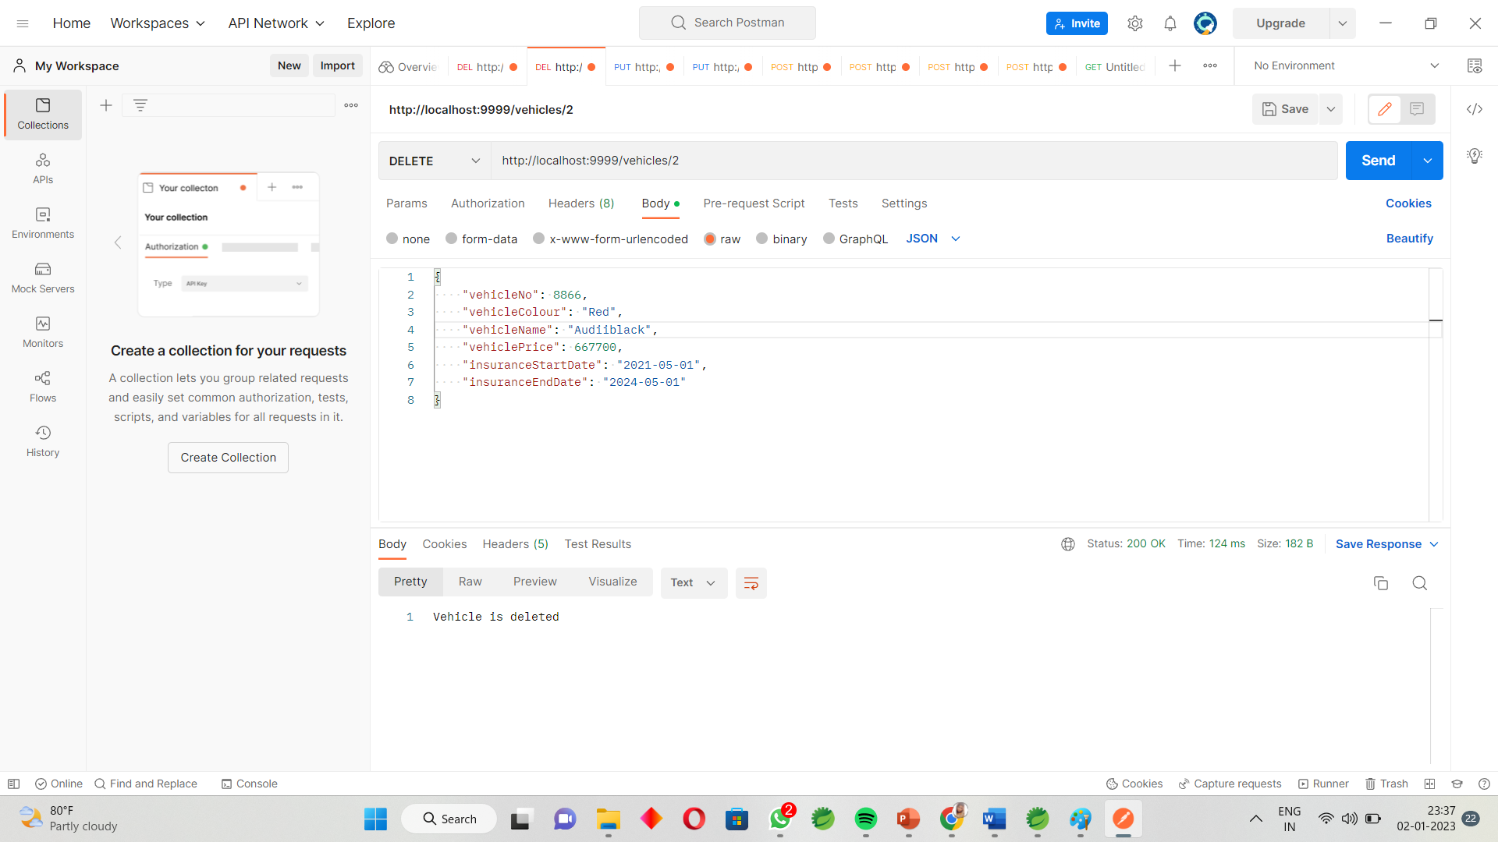

Update vehicle By id:



Get all Vehicles : 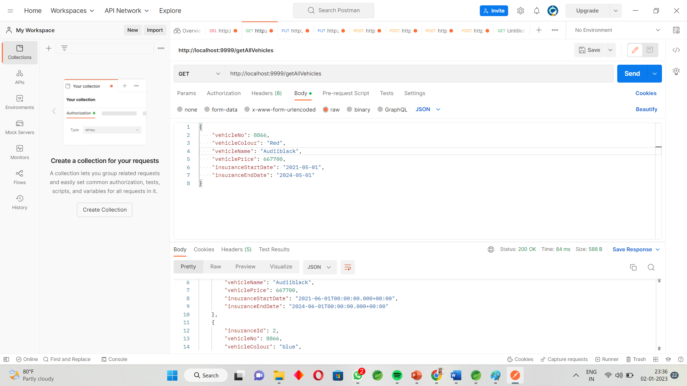

**Working Of Frontend :**

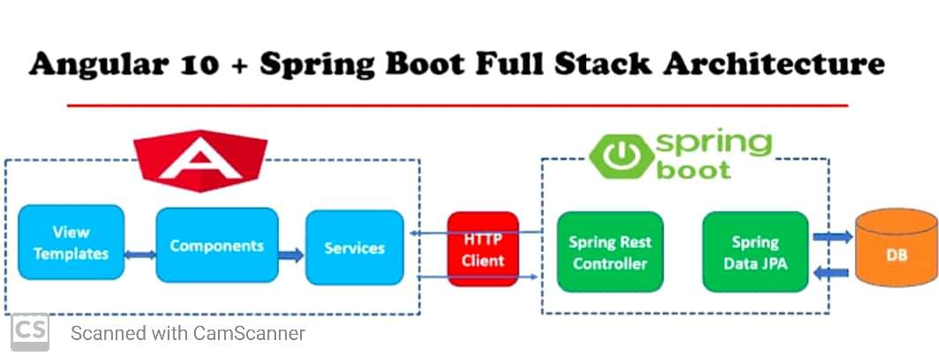

**Working Of Front-end :**

* **Once we deployed our application on the server , a**

**customer and vehicle registration form generates at the**

**web browser . The form facilitates to add and view**

**customer and vehicle details.**

* **On clicking add customer , the page redirects to create customer and vehicle form where we can add customer and vehicle by filling the required details and submit them.**
* **We can update and details the details of the customer and student . Once completed , provide the URL** [**http://localhost:4200/**](http://localhost:4200/) **at the web browser .**

**Snapshots :**

**Home Page :**

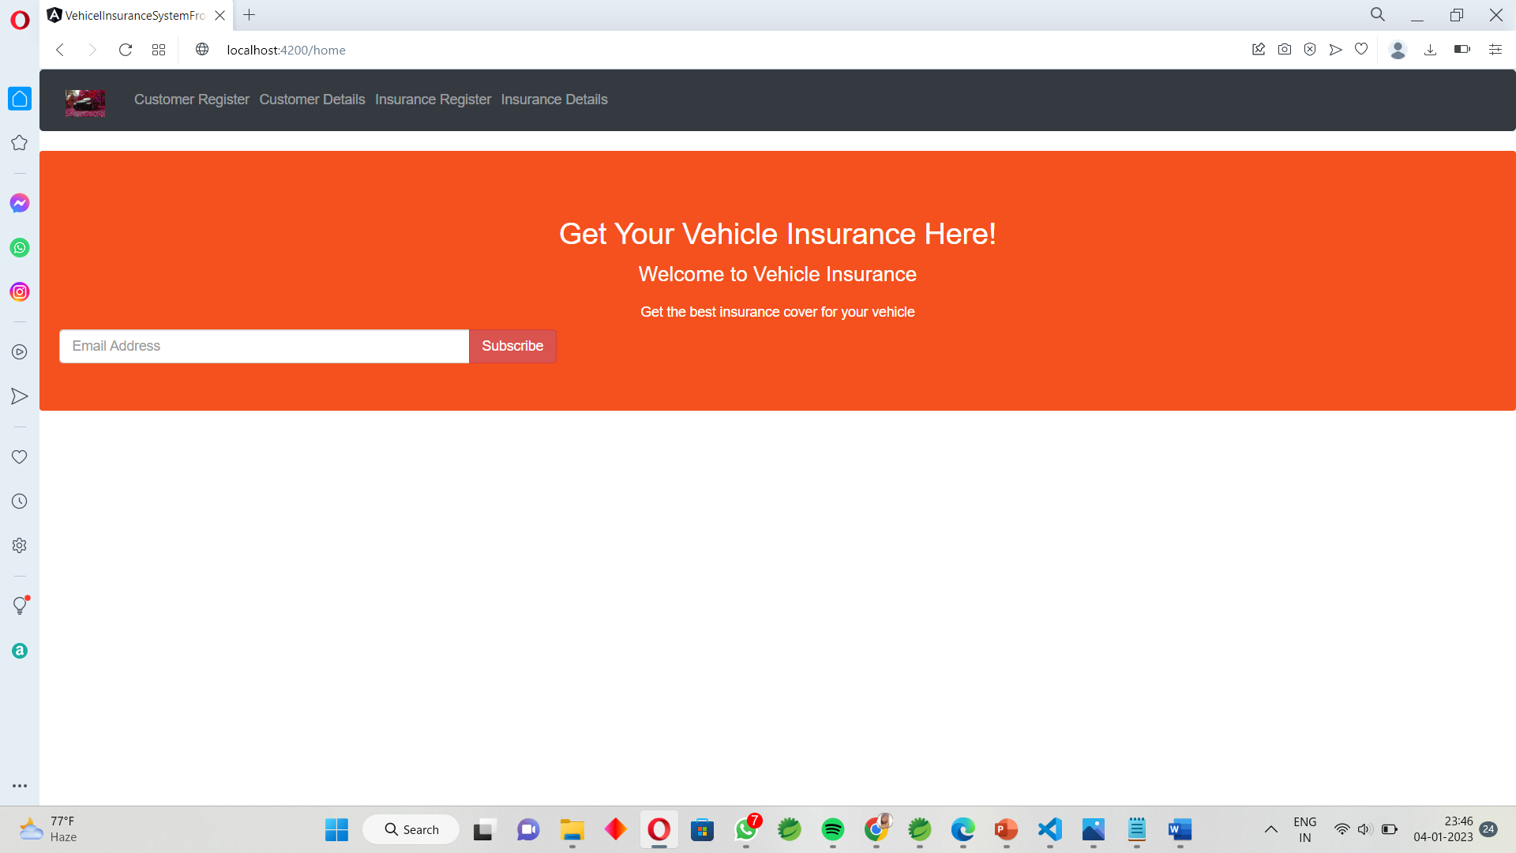

Customer Registration :

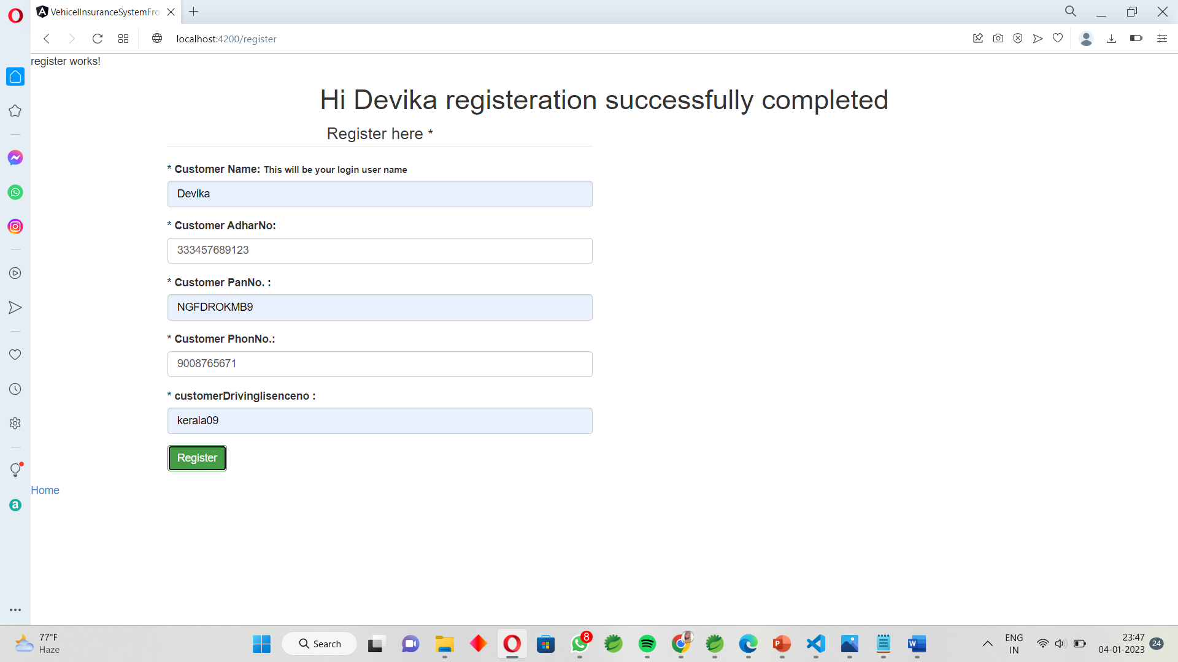

Customer Details :

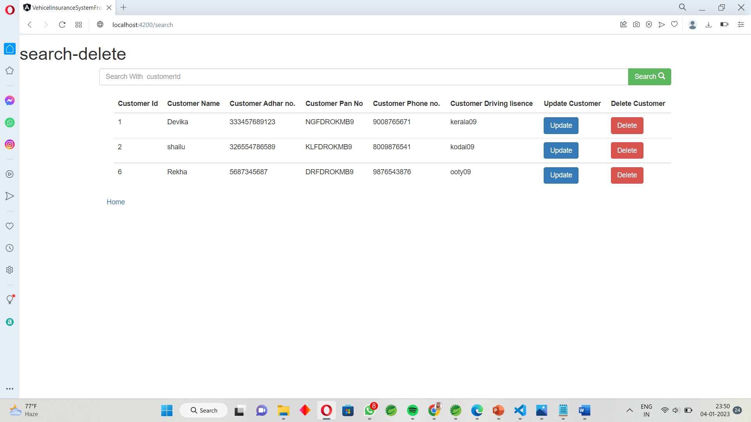

Customer Search :

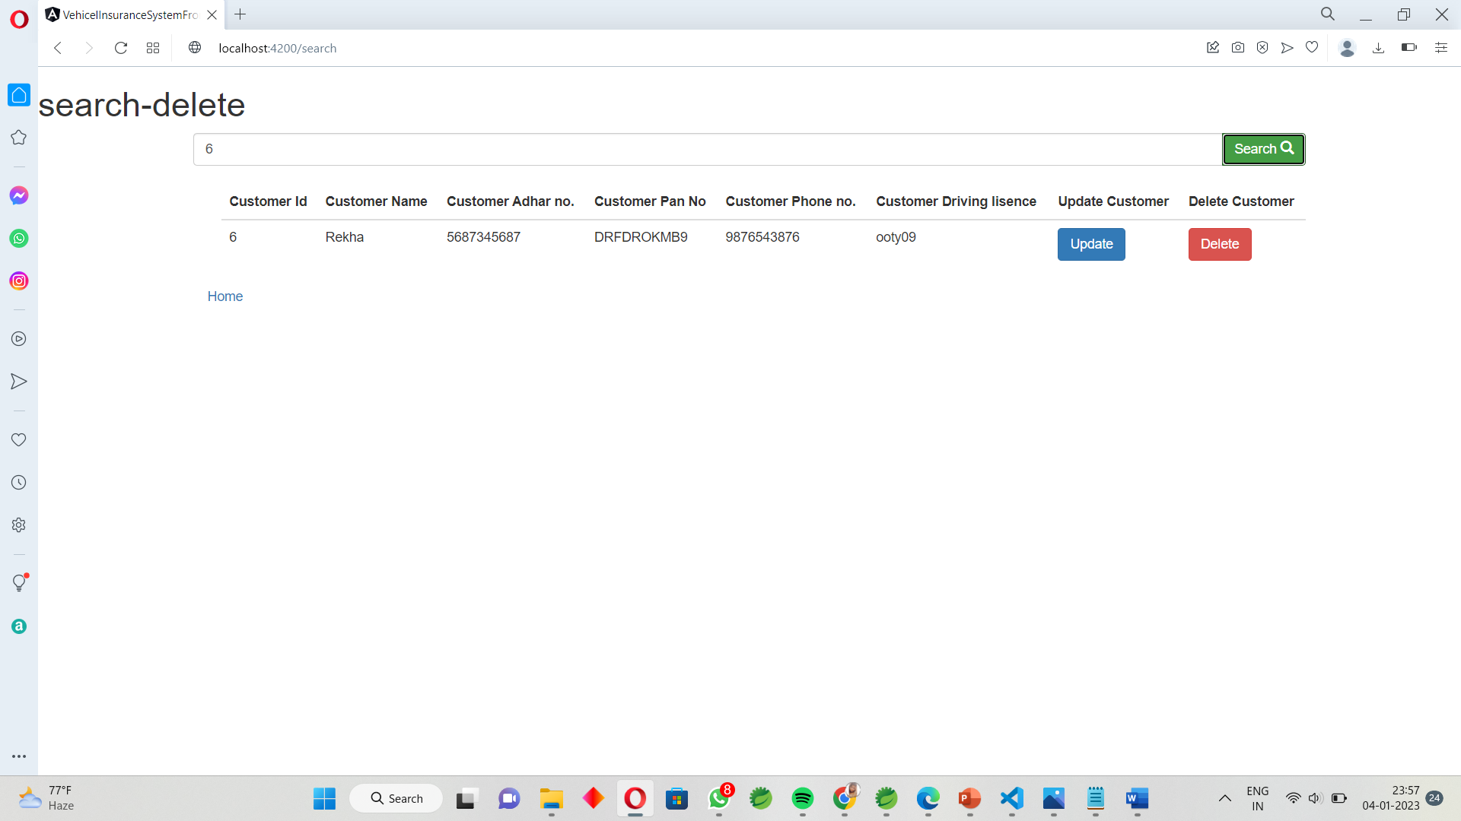

Customer Delete :

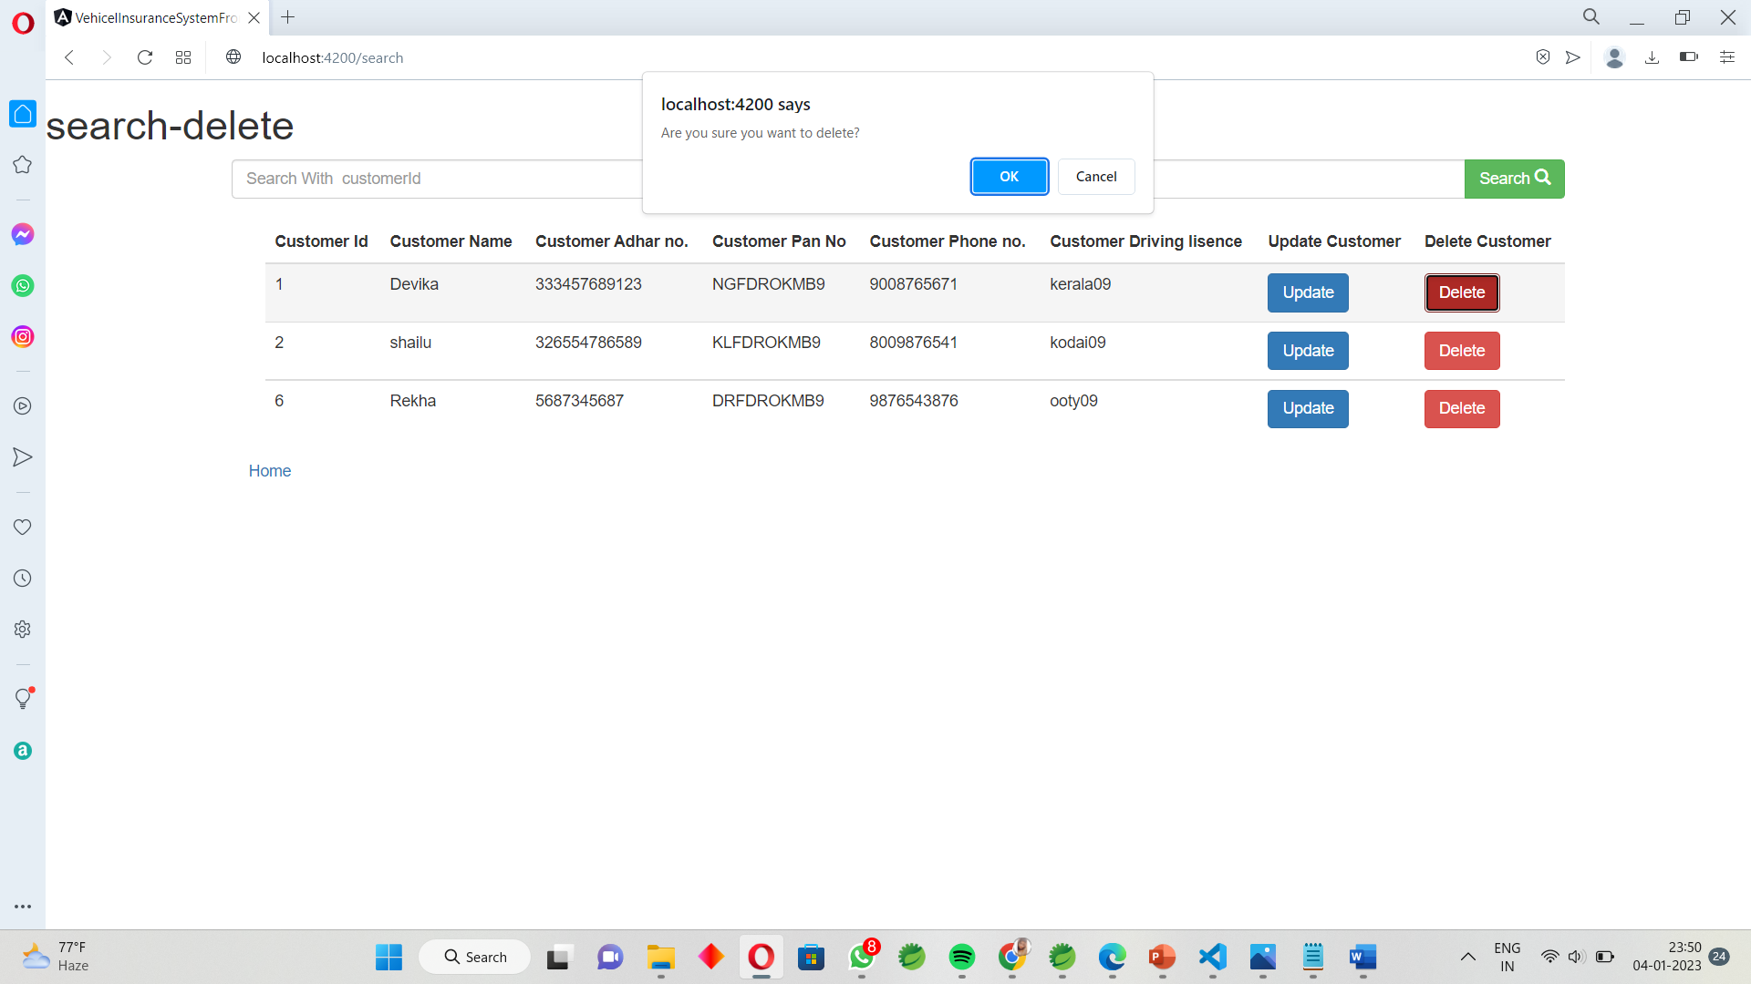

Customer Update :

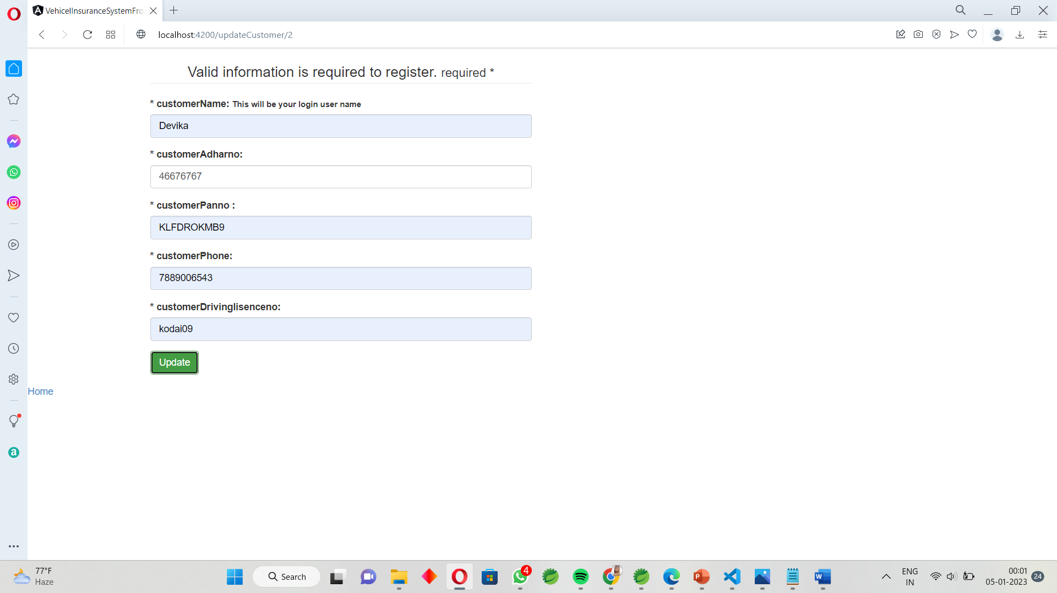

Vehicle – Registration :

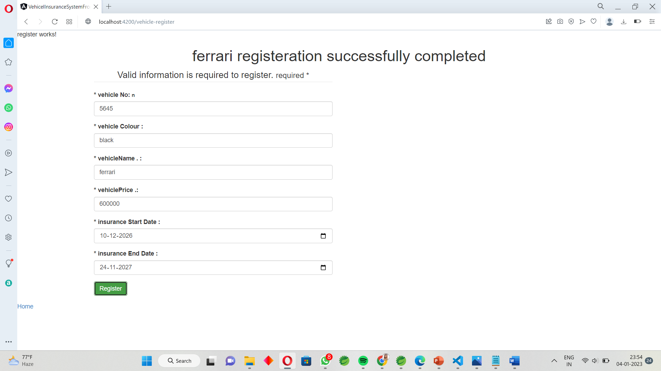

Vehicle -Details :

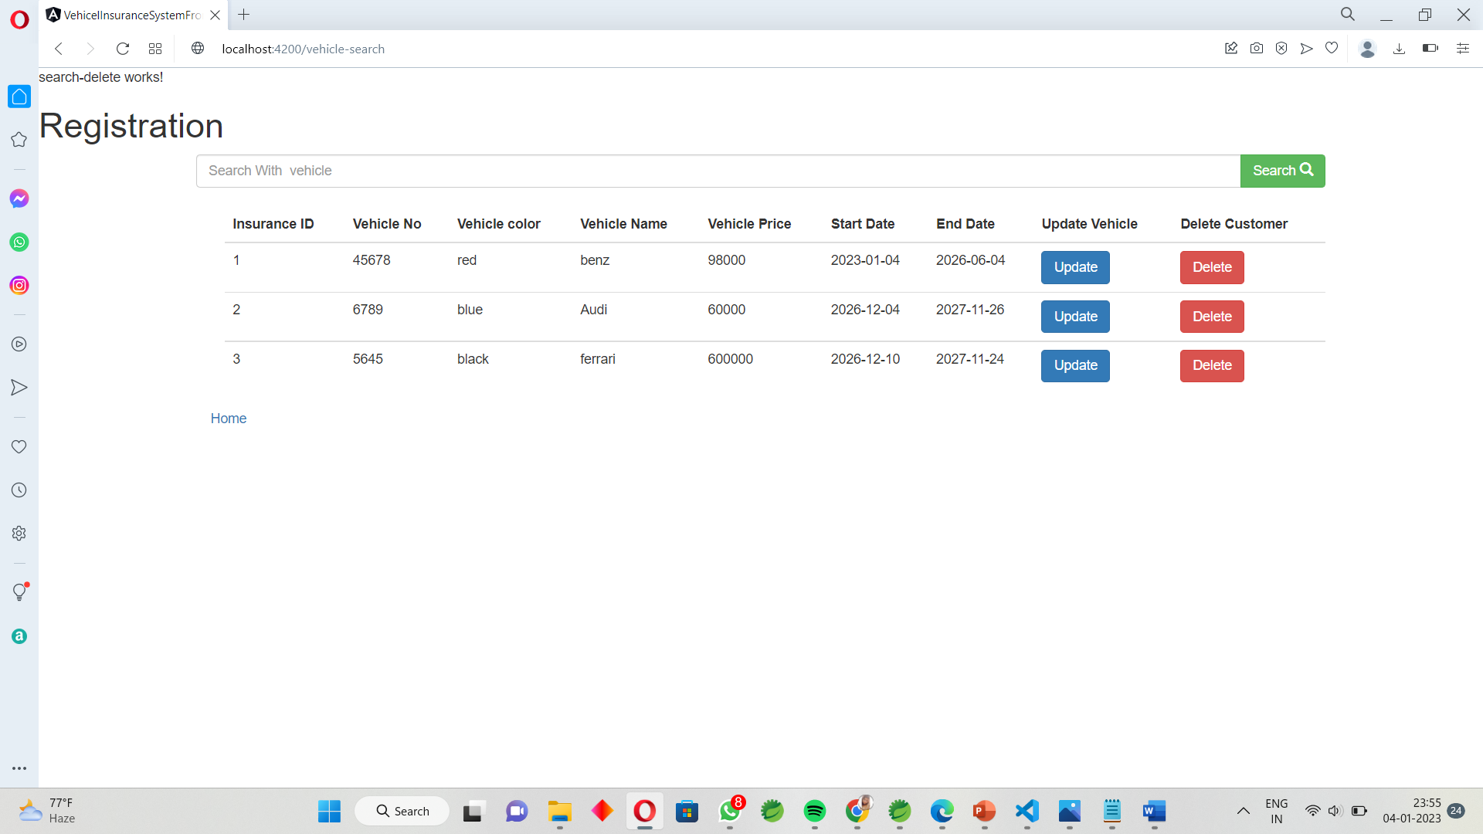

Vehicle – Delete :

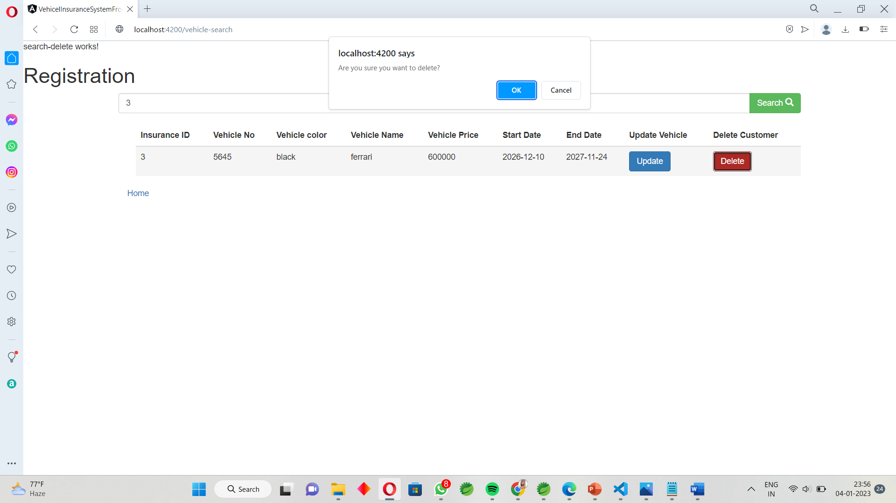

Vehicle – Search :

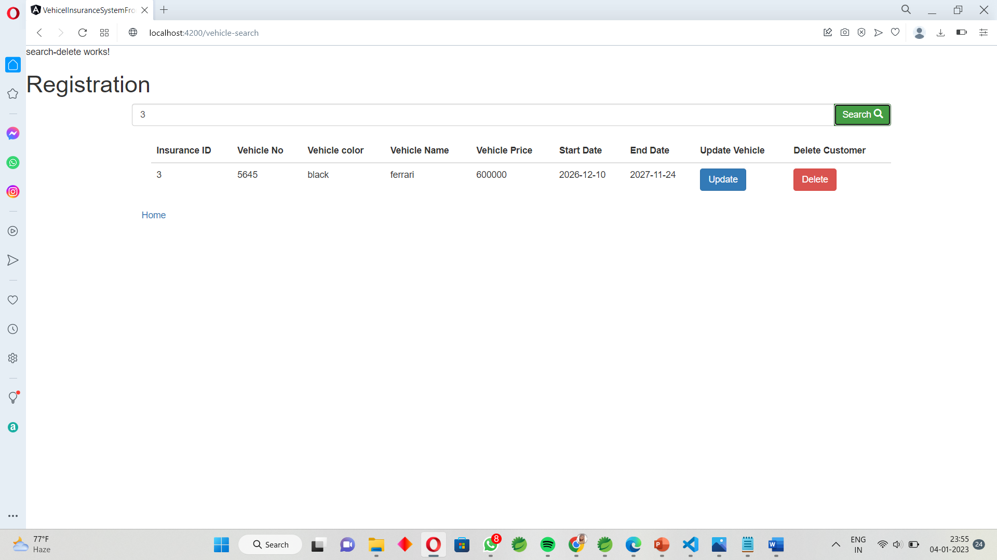

Vehicle – Update :

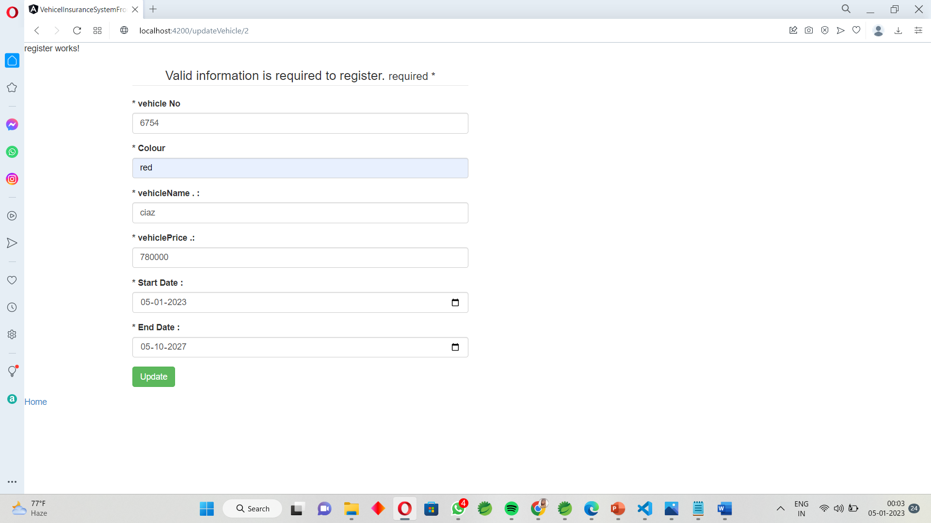

**Conclusion :**

* *The project entitled as Vehicle Insurance System is the system that deals with the registration for customer’s vehicle insurance.*
* This project is successfully implemented with all the features mentioned in system requirements specification.
* ***It provides protection in case of third-party liability along with a cover against damages to the insured vehicle or injuries caused to the owner or driver.***
* ***Along with this, comprehensive motor insurance protects your car from various damages caused due to riots, vandalism, natural disasters, theft, etc.***